**LAB REPORT**

***Submitted by***

**N. MEGHANA KIRAN [RA2011003011237]**

***Under the Guidance of***

**Dr. B. Arthi**

**Associate Professor, Computer Science and Engineering**

***In partial satisfaction of the requirements for the degree of***

**BACHELOR OF TECHNOLOGY**

**in**

**COMPUTER SCIENCE ENGINEERING**



**SCHOOL OF COMPUTING**

**COLLEGE OF ENGINEERING AND TECHNOLOGY**

**SRM INSTITUTE OF SCIENCE AND TECHNOLOGY**

**KATTANKULATHUR - 603203**

**JUNE 2022**

# 

# SRM INSTITUTION OF SCIENCE AND TECHNOLOGY KATTANKULATHUR-603203

**BONAFIDE CERTIFICATE**

Certified that this lab report titled **Airline Reservation System** is the bonafide work done by N. Meghana Kiran (RA2011003011237) who carried out the lab exercises under my supervision. Certified further, that to the best of my knowledge the work reported herein does not form part of any other work.

**SIGNATURE**

Dr. B. Arthi

**SEPM – Course Faculty**

Associate Professor

Department of Computer Science and Engineering

## ABSTRACT

Airline reservation System is a computerized system used to store and retrieve information and conduct transactions related to air travel. The project is aimed at exposing the relevance and importance of Airline Reservation Systems. It is projected towards enhancing the relationship between customers and airline agencies through the use of ARSs, and thereby making it convenient for the customers to book the flights as when they require such that they can utilize this software to make reservations. This software has two parts. First is the user part and the administrator part. User part is used as a front end and administrator is the back end. Administrator is used by airline authority. It will allow the customers to access the database and allow new customers to sign up for online access.

**TABLE OF CONTENTS**

| **CHAPTER NO** | **TITLE** | **PAGE NO** |
| --- | --- | --- |
|  |  |  |
|  | **ABSTRACT** |  |
|  | **LIST OF FIGURES** |  |
|  | **LIST OF ABBREVIATIONS** |  |
| **1** | **PROBLEM STATEMENT** | **1-3** |
| **2** | **STAKEHOLDERS & PROCESS MODELS** | **4-6** |
| **3** | **IDENTIFYING REQUIREMENTS** | **7-9** |
| **4** | **PROJECT PLAN & EFFORT** | **10-14** |
| **5** | **WORK BREAKDOWN STRUCTURE & RISK ANALYSIS** | **15-19** |
| **6**  **7**  **8**  **9**  **10**  **11**  **12** | **SYSTEM ARCHITECTURE, USE CASE & CLASS DIAGRAM**  **ENTITY RELATIONSHIP DIAGRAM**  **DATA FLOW DIAGRAM**  **SEQUENCE & COLLABORATION DIAGRAM**  **DEVELOPMENT OF TESTING FRAMEWORK/USER INTERFACE**  **TEST CASES & REPORTING**  **ARCHITECTURE/DESIGN/FRAMEWORK/IMPLE- MENTATION** | **20-24**  **25-27**  **28-30**  **31-34**  **35-39**  **40-42**  **43-45** |
|  |  |  |
|  |  |  |

**LIST OF ABBREVIATIONS**

ER -Diagram Entity Relationship

CAPEX -Capital expenditures

WBS -Work Breakdown Structure

SWOT -Strength, Weakness, Opportunities, Threats

RMMM-Risk Mitigation, Monitoring and

Management

DFD-Data flow diagram

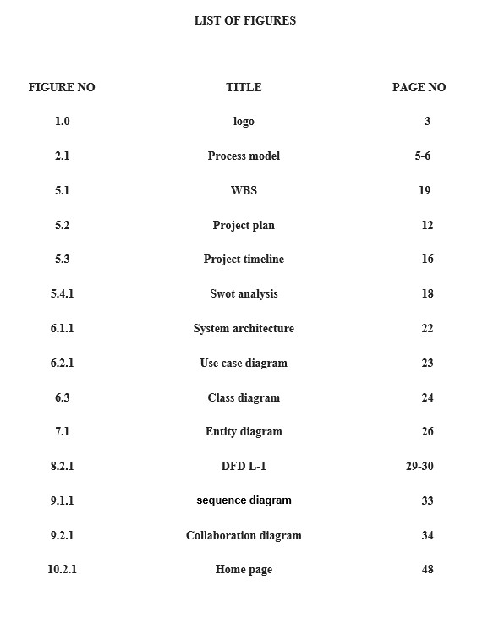



**School of Computing**

## SRM IST, Kattankulathur – 603 203 Course Code: 18CSC206J

### Course Name: Software Engineering and Project Management

|  |  |
| --- | --- |
| **Experiment No** | 1 |
| **Title of Experiment** | Test Cases |
| **Name of the candidate** | N. Meghana Kiran |
| **Team Members** | Sineha S  Aryan Tanay |
| **Register Number** | RA2011003011237  RA2011003011234  RA2011003011249 |
| **Date of Experiment** | 21/2/22 |

### Mark Split Up

|  |  |  |  |  |  |
| --- | --- | --- | --- | --- | --- |
| **S. No** |  | **Description** |  | **Maximum Mark** | **Mark Obtained** |
| 1 | Exercise |  |  | 5 |  |
| 2 | Viva |  |  | 5 |  |
|  | |  | **Total** | **10** |  |

## Staff Signature with date

**Aim**

To create business case and arrive at a problem statement.

**Team Members:**

|  |  |  |  |
| --- | --- | --- | --- |
| **S No** | **Register No** | **Name** | **Role** |
| **1** | RA2011003011234 | Sineha S | **Rep** |
| **2** | RA2011003011237 | N. Meghana Kiran | **Member** |
| **3** | RA2011003011249 | Aryan Tanay | **Member** |

### AIRLINE RESERVATION SYSTEM

**Project Description:**

* The main objective of the Airlines Reservation System is to manage the details of

Airlines Ticket, Flights, Customer, Booking Counter, Venders.

* It manages all the information about Airlines Ticket, Bookings, Vendors, Airlines

Ticket.

* It aims at solving the problems faced in airline booking.

Result:

Thus, the project team formed, the project is described, the business case was prepared and the problem statement was arrived.

**Business Case**

**ONE PAGE BUSINESS CASE TEMPLATE**

|  |  |
| --- | --- |
| **DATE** | 21/02/22 |
| **SUBMITTED BY** | SINEHA S  N. MEGHANA KIRAN  ARYAN TANAY |
| **TITLE / ROLE** | AIRLINE TICKET BOOKING SYSTEM |

**THE PROJECT**

In bullet points, describe the problem this project aims to solve or the opportunity it aims to develop.

|  |  |
| --- | --- |
| ● | Ticket slots are already booked by other third-party apps and websites which leaves less seats for the passengers to book directly via the airline website. |
| ● | Sometimes, the bad reviews and complaints of customers and passengers are hidden and are not displayed in front for other future travelers to assess the airline, which makes their travel difficult. |
| ● | Websites hide and not let you apply coupon codes which will decrease their commission on flight ticket bookings. This problem persists in all the websites and apps for airfare booking. |

|  |  |
| --- | --- |
| ● | Ability to solve the problem using a new program to make flight ticket booking easier. |
| ● | Knowledge of programming languages |

|  |  |
| --- | --- |
| ● | slot management |
| ● | handling customer complaints |
| ● | apply coupon codes |

|  |  |
| --- | --- |
| ● | Ego problem persists with the owners of the websites and apps, as their commission and service costs will be cut. |
| ● | Owners will not be happy if the reviews are against them. |
| ● | Lack of valid coupons that can be used on specific websites. |

#### THE HISTORY

In bullet points, describe the current situation.

#### LIMITATIONS

List what could prevent the success of the project, such as the need for expensive equipment, bad weather, lack of special training, etc.

**APPROACH**

List what is needed to complete the project.

|  |  |
| --- | --- |
| ● | More verified seats will be booked, there will be no fake passengers created by bots for the profit of the airlines. |
| ● | Airlines will be able to create/maintain a good track record of their service by taking reviews. |
| ● | More passengers will be attracted towards booking the flights as they will be given more coupons which will give them a lesser price to travel on. |

#### BENEFITS

In bullet points, list the benefits that this project will bring to the organization.



**School of Computing**

## SRM IST, Kattankulathur – 603 203 Course Code: 18CSC206J

### Course Name: Software Engineering and Project Management

|  |  |
| --- | --- |
| **Experiment No** | 2 |
| **Title of Experiment** | Test Cases |
| **Name of the candidate** | N. Meghana Kiran |
| **Team Members** | Sineha S  Aryan Tanay |
| **Register Number** | RA2011003011234  RA2011003011237  RA2011003011249 |
| **Date of Experiment** | 23/3/22 |

### Mark Split Up

|  |  |  |  |  |  |
| --- | --- | --- | --- | --- | --- |
| **S. No** |  | **Description** |  | **Maximum Mark** | **Mark Obtained** |
| 1 | Exercise |  |  | 5 |  |
| 2 | Viva |  |  | 5 |  |
|  | |  | **Total** | **10** |  |

## Staff Signature with date

**Aim**

To identify the appropriate Process Model for the project and prepare Stakeholder and User Description.

**Team Members:**

|  |  |  |  |
| --- | --- | --- | --- |
| **S No** | **Register No** | **Name** | **Role** |
| **1** | RA2011003011234 | Sineha S | **Rep** |
| **2** | RA2011003011237 | N. Meghana Kiran | **Member** |
| **3** | RA2011003011249 | Aryan Tanay | **Member** |

**Selection of Methodology**

**Agile development methodology:**

* This methodology best suits our project because in our project we focus to

minimize the risk such as bugs, cost overruns, and changing requirements.

* Also, it involves constant collaboration with stakeholders and

continuous improvement at every stage.

* It enables teams to deliver value faster, with greater quality and greater aptitude to respond to change.

|  |  |  |  |  |
| --- | --- | --- | --- | --- |
| Stakeholder  Name | Activity/ Area  /Phase | Interest | Influence | Priority (High/  Medium/ Low) |
| Team leader | Responsible for  planning, executing and promoting the activities that a | High | High | 1 |
|  | project undertakes. |  |  |  |
| Member | Play a defining role in the strategy, tactics, and operations the team carries out. | High | High | 1 |
| Supervisor | Supervise and verifies the progress of the project. | High | Mid | 2 |
| Tamil Nādu govt | Provides the necessary funding and resources. | Mid | High | 3 |
| Local tourist guide | Provides information and pictures of the place. | Mid | Mid | 2 |
| User | Provide feedback. | Low | Mid | 4 |

Result

Thus the Project Methodology was identified and the stakeholders were described.



**School of Computing**

## SRM IST, Kattankulathur – 603 203 Course Code: 18CSC206J

### Course Name: Software Engineering and Project Management

|  |  |
| --- | --- |
| **Experiment No** | 3 |
| **Title of Experiment** | Test Cases |
| **Name of the candidate** | N. Meghana Kiran |
| **Team Members** | Sineha S  Aryan Tanay |
| **Register Number** | RA2011003011237  RA2011003011234  RA2011003011249 |
| **Date of Experiment** | 30/3/22 |

### Mark Split Up

|  |  |  |  |  |  |
| --- | --- | --- | --- | --- | --- |
| **S. No** |  | **Description** |  | **Maximum Mark** | **Mark Obtained** |
| 1 | Exercise |  |  | 5 |  |
| 2 | Viva |  |  | 5 |  |
|  | |  | **Total** | **10** |  |

## Staff Signature with date

**Aim**

To identify functional and non-functional requirements.

**Team Members:**

|  |  |  |  |
| --- | --- | --- | --- |
| **S No** | **Register No** | **Name** | **Role** |
| **1** | RA2011003011234 | Sineha S | **Rep** |
| **2** | RA2011003011237 | N. Meghana Kiran | **Member** |
| **3** | RA2011003011249 | Aryan Tanay | **Member** |

**System Requirements:**

**Hardware Requirements**

* For the hardware requirements like memory restrictions, cache size, the processor, RAM size etc those are required for the software to run.

**MINIMUM Hardware Requirements**

* Processor Pentium IV
* Hard Disk Drive 100 GB
* RAM 1 Gb

**PREFERED HARDWARE REQUIREMENTS**

* Processor Core i3
* Hard Disk Drive 500 GB
* RAM 4 GB

**Software Requirements**

* Any window-based operating system with DOS support are primary requirements for software development.
* Windows 7 and up are required. The system must be connected via LAN and connected to the internet is mandatory.

**Functional Requirements:**

* Customers should be able to search flights for a specific date for one-way trips.
* Customers should be able to specify the travel class while searching for a flight.
* Customer should be able to see all the possible flights based on the information he entered.
* Customers should be able to select the type of the ticket.
* System should allow the customer to book the ticket to a flight of his choice.

**Non-Functional Requirements:**

* System should be able to handle 1000 transactions per second.
* System should have an Authentication and Authorization System (AAS) for logins.
* System should allow the administrator to login with a customized password.
* System should block access to one who fails to login three times in a row.
* System should include restore and recover functions in order to prevent data loss.



**School of Computing**

## SRM IST, Kattankulathur – 603 203 Course Code: 18CSC206J

### Course Name: Software Engineering and Project Management

|  |  |
| --- | --- |
| **Experiment No** | 4 |
| **Title of Experiment** | Test Cases |
| **Name of the candidate** | N. Meghana Kiran |
| **Team Members** | Sineha S  Aryan Tanay |
| **Register Number** | RA2011003011237  RA2011003011234  RA2011003011249 |
| **Date of Experiment** | 6/4/22 |

### Mark Split Up

|  |  |  |  |  |  |
| --- | --- | --- | --- | --- | --- |
| **S. No** |  | **Description** |  | **Maximum Mark** | **Mark Obtained** |
| 1 | Exercise |  |  | 5 |  |
| 2 | Viva |  |  | 5 |  |
|  | |  | **Total** | **10** |  |

## Staff Signature with date

**Aim**

To prepare project based plan on scope, calculate project efforts on resources, find job roles and responsibilities.

**Team Members:**

|  |  |  |  |
| --- | --- | --- | --- |
| **S No** | **Register No** | **Name** | **Role** |
| **1** | RA2011003011234 | Sineha S | **Rep** |
| **2** | RA2011003011237 | N. Meghana Kiran | **Member** |
| **3** | RA2011003011249 | Aryan Tanay | **Member** |

**REQUIREMENTS:**

1. Project Management Plan

Describe the key issues driving the project. **[Min 3 Focus Areas]**

|  |  |
| --- | --- |
| **Focus Area** | **Details** |
| Integration Management | Governance Framework  Project Team Structure  Roles & Responsibilities of Team  Change Management  (Change Control, Issue Management)  Project Closure |
| Schedule Management | Define Milestones  Schedule Control |
| Cost Management | Estimate Effort  Assign Team  Budget Control |
| Quality Management | Quality Assurance: Quality assurance will be managed including governance, roles and responsibilities, tools and techniques and reporting |
|  | Quality Control: Specify the mechanisms to be used to measure and control the quality of the work products |
| Stakeholder | Identifying, Analyzing, Engaging Stakeholders |

1. Estimation
   1. Effort and Cost Estimation

|  |  |  |  |  |  |  |
| --- | --- | --- | --- | --- | --- | --- |
| **Activity Description** | | | **Sub-Task** | **Sub-Task Description** | **Effort (in hours)** | **Cost in**  **INR** |
| Login | | | Sign up | User will fill his/her email id and password | 3 | 3000 |
| Verification | Verification of login will be done via email |  |  |
| Sign in | Now user will be signed in to the system |  |  |
| Booking | | | Registration | User can register with their email id and phone number | 5 | 5000 |
| Verification | verification via sms |  |  |
| Payment | | | Billing and payment | The bill will be  generated and payment will be done | 5 | 5000 |
|  | | |  |  | 3 | 3000 |
| Confirmation | | | Confirmation of booking | Ticket booking and reservation will be confirmed via a document |  |  |
| **Effort (hr)** | **Cost (INR)** |
| 1 | 500 |

* 1. Infrastructure/Resource Cost [CapEx]

|  |  |  |  |
| --- | --- | --- | --- |
| **Infrastructure**  **Requirement** | **Qty** | **Cost per qty** | **Cost per item** |
| database | 5 | 1,00,000 | 5,00,000 |

* 1. Maintenance and Support Cost [OpEx]

|  |  |  |  |  |
| --- | --- | --- | --- | --- |
| **Category** | **Details** | **Qty** | **Cost per qty per**  **annum** | **Cost per item** |
| People | Network, System,  Middleware and DB admin  Developer, Support  Consultant | 3 | 2,000,000 | 6,000,000 |
| License | Operating System  Database  Middleware  IDE | 10 | 10000 | 100,000 |
| Infrastructures | Server, Storage and Network | 20 | 20000 | 400,000 |

1. Project Team Formation
   1. Identification Team members

|  |  |  |
| --- | --- | --- |
| **Name** | **Role** | **Responsibilities** |
|  | Key Business User (Product  Owner) | Provide clear business and user requirements |
| Sineha S | Project Manager  Backend Developer  Technical Lead | Manage the project  Design, Develop and Unit Test  Services/API/DB  Design the end-to-end architecture |
| N. Meghana Kiran | Business Analyst  Cloud Architect  UX Designer | Discuss and Document Requirements  Design the cost effective, highly available  and scalable architecture Design the user experience |
| Aryan Tanay | Frontend developer Tester | Develop user interface  Define Test Cases and Perform Testing |

|  |  |
| --- | --- |
| A | Accountable |
| R | Responsible |
| C | Consult |
| I | Inform |

* 1. Responsibility Assignment Matrix

|  |  |  |  |  |
| --- | --- | --- | --- | --- |
| **RACI Matrix** |  | **Team Members** | |  |
| **Activity** | **Meghana (BA)** | **Aryan (Developer)** | **Sineha (Project**  **Manager)** | **Key Business User** |
| User Requirement Documentation | A | C/I | I | R |
| Management | A | A | R | I |
| Project  Development | A | R | C/I | C |
| Cost estimation and documentation | R | A | A | C/I |



**School of Computing**

## SRM IST, Kattankulathur – 603 203 Course Code: 18CSC206J

### Course Name: Software Engineering and Project Management

|  |  |
| --- | --- |
| **Experiment No** | 5 |
| **Title of Experiment** | Test Cases |
| **Name of the candidate** | N. Meghana Kiran |
| **Team Members** | Sineha S  Aryan Tanay |
| **Register Number** | RA2011003011237  RA2011003011234 |
|  | RA2011003011249 |
| **Date of Experiment** | 22/4/22 |

### Mark Split Up

|  |  |  |  |  |  |
| --- | --- | --- | --- | --- | --- |
| **S. No** |  | **Description** |  | **Maximum Mark** | **Mark Obtained** |
| 1 | Exercise |  |  | 5 |  |
| 2 | Viva |  |  | 5 |  |
|  |  |  | **Total** | **10** |  |

## Staff Signature with date

**Aim**

To prepare work breakdown structure and timeline chart.

**Team Members:**

|  |  |  |  |
| --- | --- | --- | --- |
| **S No** | **Register No** | **Name** | **Role** |
| **1** | RA2011003011234 | Sineha S | **Rep** |
| **2** | RA2011003011237 | N. Meghana Kiran | **Member** |
| **3** | RA2011003011249 | Aryan Tanay | **Member** |

**TIMELINE – GANTT CHART**

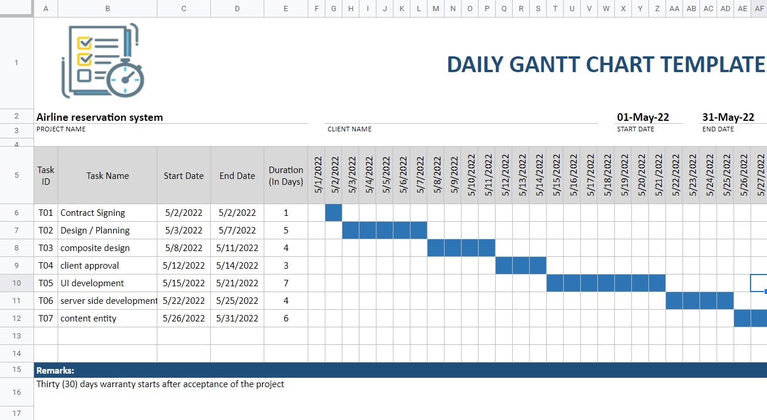

**WBS**

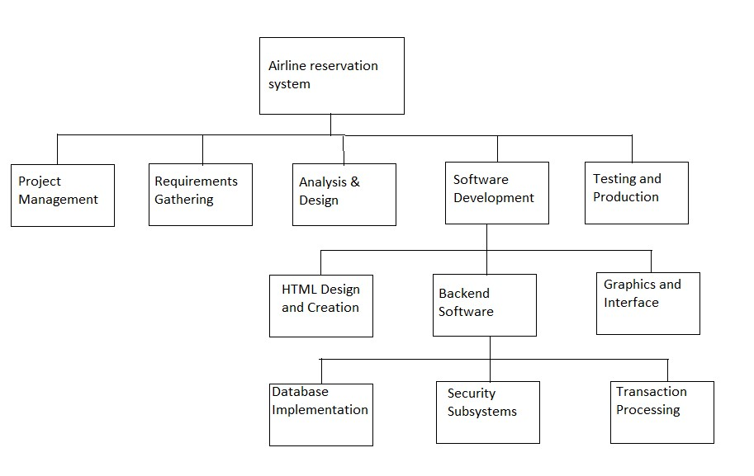

0.0 Airline reservation system

1.0 Project Management

2.0 Requirements Gathering

3.0 Analysis & Design

4.0 Software Development

◦ 4.1 HTML Design and Creation

◦ 4.2 Backend Software

* 4.2.1 Database Implementation
* 4.2.2 Security Subsystems
* 4.2.3 Transaction Processing

◦ 4.3 Graphics and Interface

5.0 Testing and Production

**RISK ANALYSIS – SWOT & RMMM**

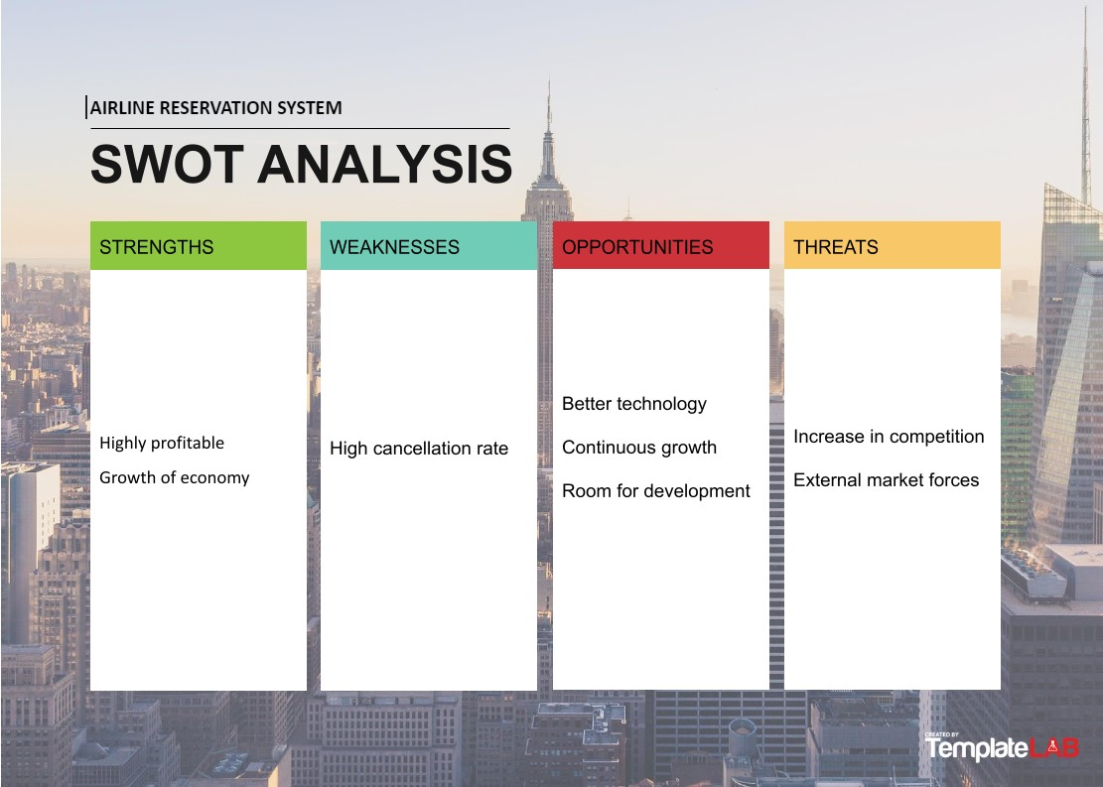

## RMMM

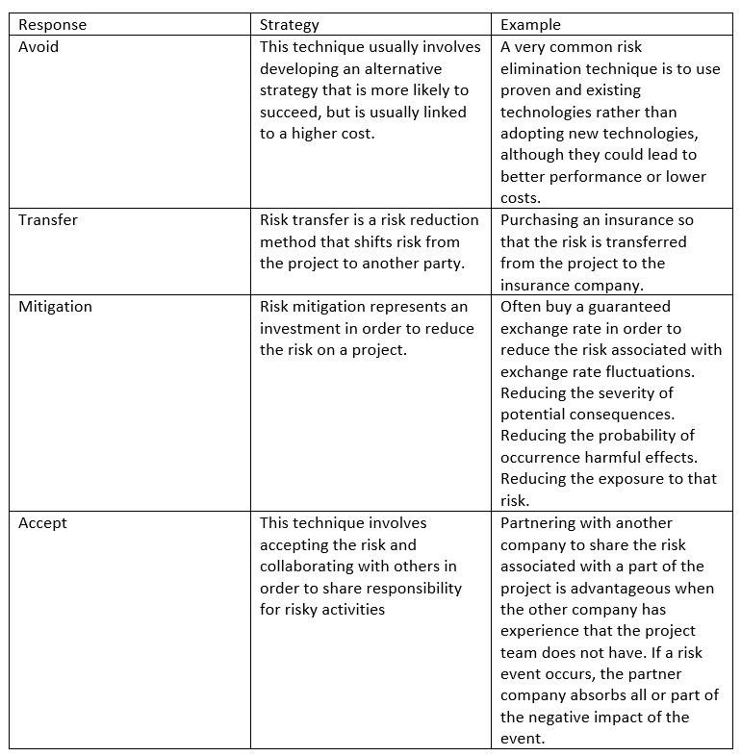



**School of Computing**

## SRM IST, Kattankulathur – 603 203 Course Code: 18CSC206J

### Course Name: Software Engineering and Project Management

|  |  |
| --- | --- |
| **Experiment No** | 6 |
| **Title of Experiment** | Test Cases |
| **Name of the candidate** | N. Meghana Kiran |
| **Team Members** | Sineha S  Aryan Tanay |
| **Register Number** | RA2011003011237  RA2011003011234  RA2011003011249 |
| **Date of Experiment** | 24/9/22 |

### Mark Split Up

|  |  |  |  |  |  |
| --- | --- | --- | --- | --- | --- |
| **S. No** |  | **Description** |  | **Maximum Mark** | **Mark Obtained** |
| 1 | Exercise |  |  | 5 |  |
| 2 | Viva |  |  | 5 |  |
|  |  |  | **Total** | **10** |  |

## Staff Signature with date

**Aim**

To design a system architecture, use case and class diagram.

**Team Members:**

|  |  |  |  |
| --- | --- | --- | --- |
| **S No** | **Register No** | **Name** | **Role** |
| **1** | RA2011003011234 | Sineha S | **Rep** |
| **2** | RA2011003011237 | N. Meghana Kiran | **Member** |
| **3** | RA2011003011249 | Aryan Tanay | **Member** |

**system architecture:**

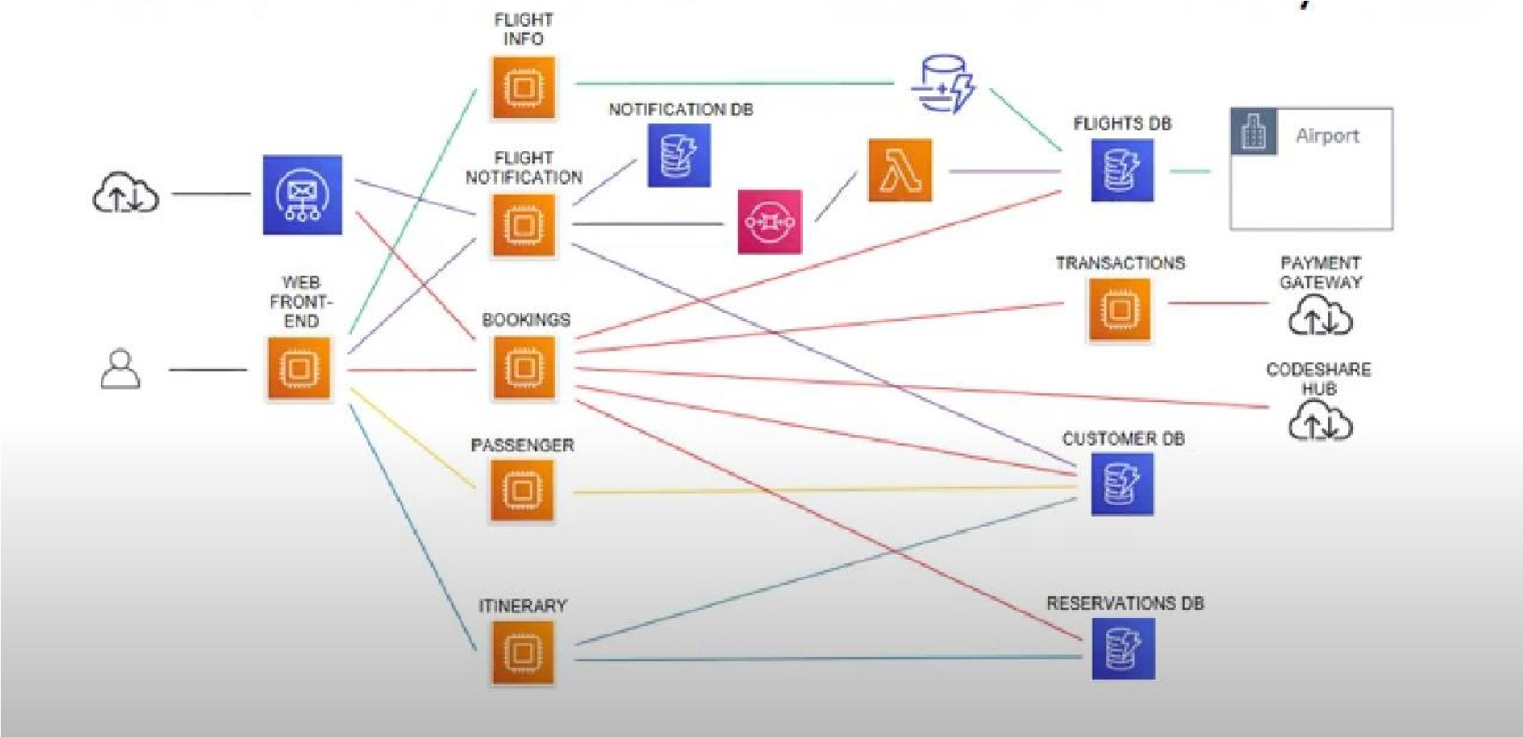

**use case diagram:**

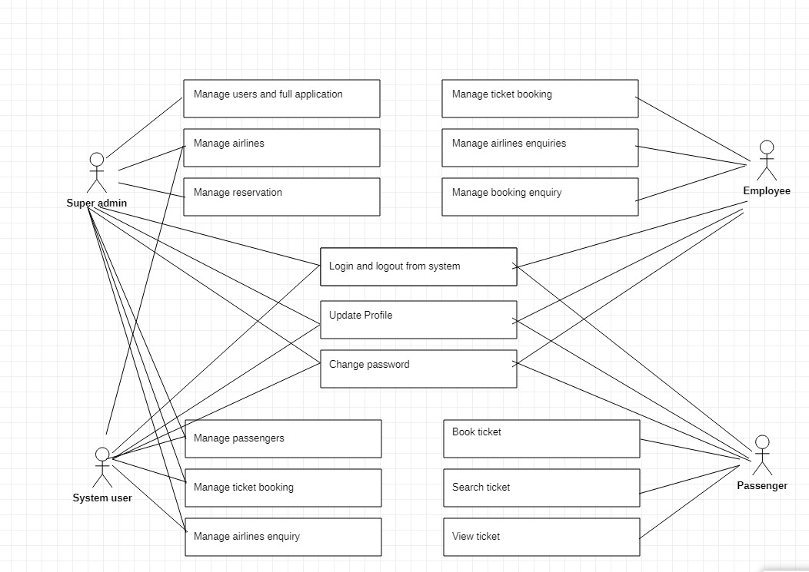

**Ulm class diagram:**

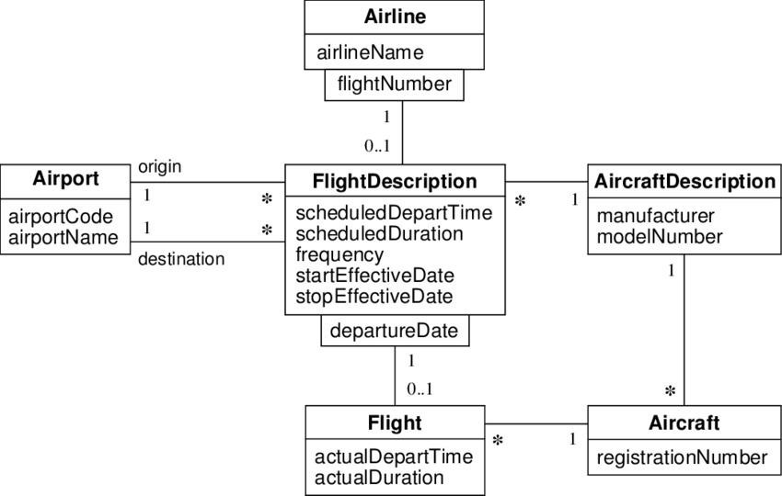



**School of Computing**

## SRM IST, Kattankulathur – 603 203 Course Code: 18CSC206J

### Course Name: Software Engineering and Project Management

|  |  |
| --- | --- |
| **Experiment No** | 7 |
| **Title of Experiment** | Test Cases |
| **Name of the candidate** | N. Meghana Kiran |
| **Team Members** | Sineha S  Aryan Tanay |
| **Register Number** | RA2011003011237  RA2011003011234  RA2011003011249 |
| **Date of Experiment** | 9/5/22 |

### Mark Split Up

|  |  |  |  |  |  |
| --- | --- | --- | --- | --- | --- |
| **S. No** |  | **Description** |  | **Maximum Mark** | **Mark Obtained** |
| 1 | Exercise |  |  | 5 |  |
| 2 | Viva |  |  | 5 |  |
|  | |  | **Total** | **10** |  |

## Staff Signature with date

**Aim**

To develop the test cases manual for the airline reservation system.

**Team Members:**

|  |  |  |  |
| --- | --- | --- | --- |
| **S No** | **Register No** | **Name** | **Role** |
| **1** | RA2011003011234 | Sineha S | **Rep** |
| **2** | RA2011003011237 | N. Meghana Kiran | **Member** |
| **3** | RA2011003011249 | Aryan Tanay | **Member** |

ER Diagram :

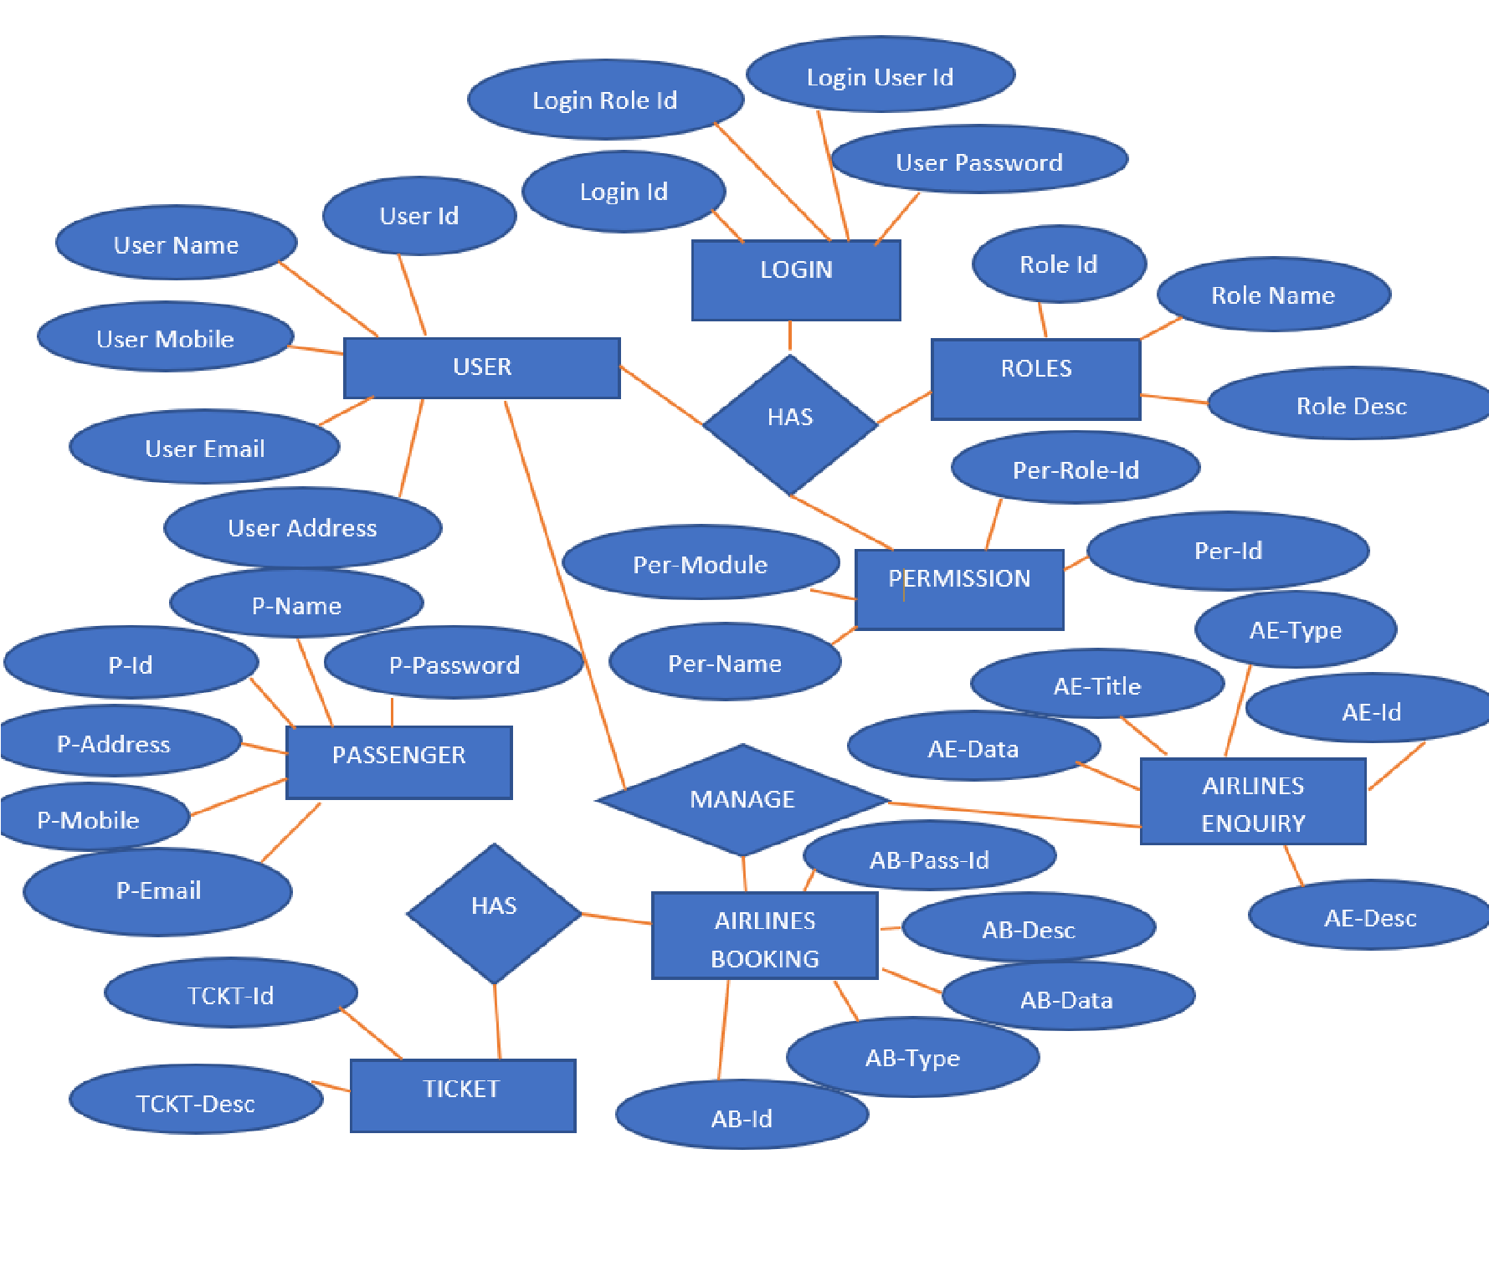



**School of Computing**

## SRM IST, Kattankulathur – 603 203 Course Code: 18CSC206J

### Course Name: Software Engineering and Project Management

|  |  |
| --- | --- |
| **Experiment No** | 8 |
| **Title of Experiment** | Test Cases |
| **Name of the candidate** | N. Meghana Kiran |
| **Team Members** | Sineha S  Aryan Tanay |
| **Register Number** | RA2011003011237  RA2011003011234  RA2011003011249 |
| **Date of Experiment** | 16/5/22 |

### Mark Split Up

|  |  |  |  |  |  |
| --- | --- | --- | --- | --- | --- |
| **S. No** |  | **Description** |  | **Maximum Mark** | **Mark Obtained** |
| 1 | Exercise |  |  | 5 |  |
| 2 | Viva |  |  | 5 |  |
|  | |  | **Total** | **10** |  |

## Staff Signature with date

**Aim**

To develop data flow diagram.

**Team Members:**

|  |  |  |  |
| --- | --- | --- | --- |
| **S No** | **Register No** | **Name** | **Role** |
| **1** | RA2011003011234 | Sineha S | **Rep** |
| **2** | RA2011003011237 | N. Meghana Kiran | **Member** |
| **3** | RA2011003011249 | Aryan Tanay | **Member** |

**Data Flow Diagram:**

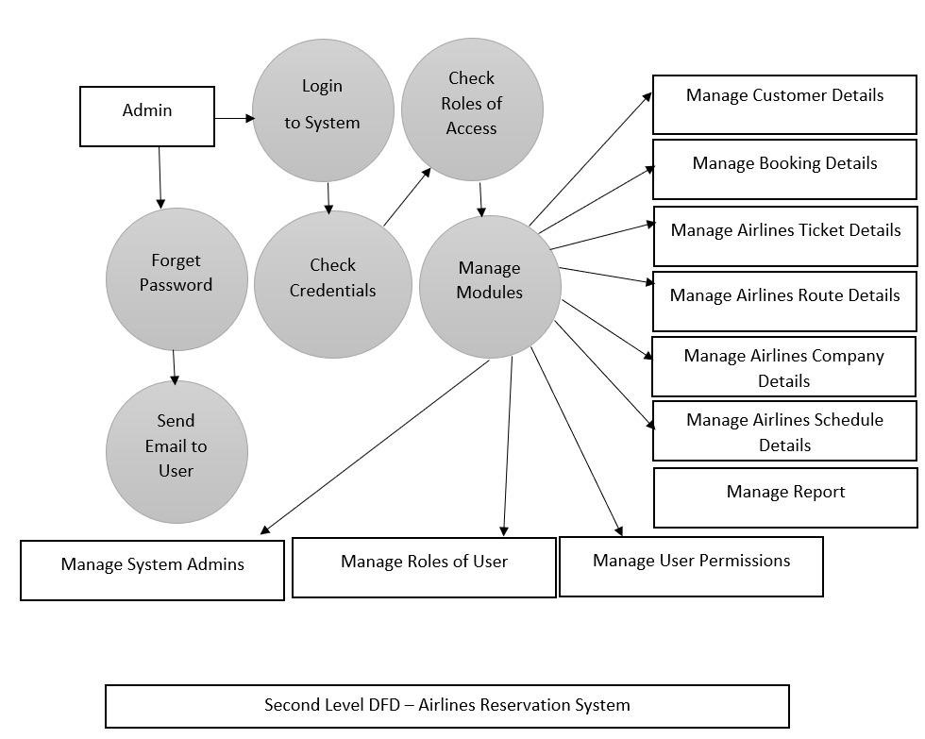

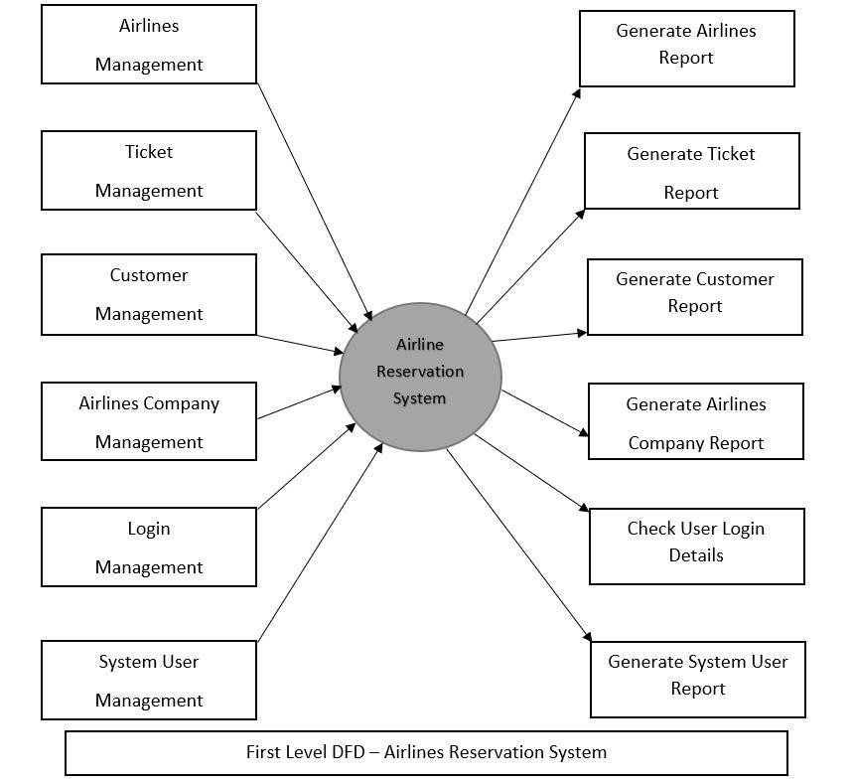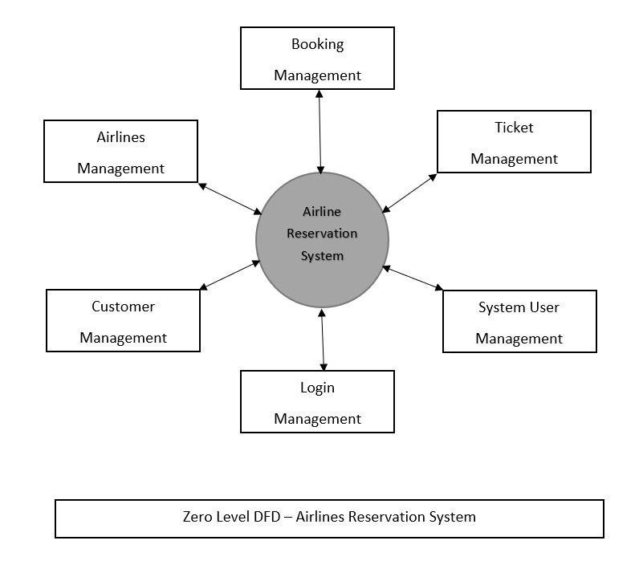



**School of Computing**

## SRM IST, Kattankulathur – 603 203 Course Code: 18CSC206J

|  |  |  |  |  |  |
| --- | --- | --- | --- | --- | --- |
| **S. No** |  | **Description** |  | **Maximum Mark** | **Mark Obtained** |
| 1 | Exercise |  |  | 5 |  |
| 2 | Viva |  |  | 5 |  |
|  | |  | **Total** | **10** |  |

### Course Name: Software Engineering and Project Management

|  |  |
| --- | --- |
| **Experiment No** | 9 |
| **Title of Experiment** | Test Cases |
| **Name of the candidate** | N. Meghana Kiran |
| **Team Members** | Sineha S  Aryan Tanay |
| **Register Number** | RA2011003011237  RA2011003011234  RA2011003011249 |
| **Date of Experiment** | 23/5/22 |

**Mark Split Up**

## Staff Signature with date

**Aim**

To develop the sequence and collaboration diagram.

**Team Members:**

|  |  |  |  |
| --- | --- | --- | --- |
| **S No** | **Register No** | **Name** | **Role** |
| **1** | RA2011003011234 | Sineha S | **Rep** |
| **2** | RA2011003011237 | N. Meghana Kiran | **Member** |
| **3** | RA2011003011249 | Aryan Tanay | **Member** |

SEQUENCE DIAGRAM

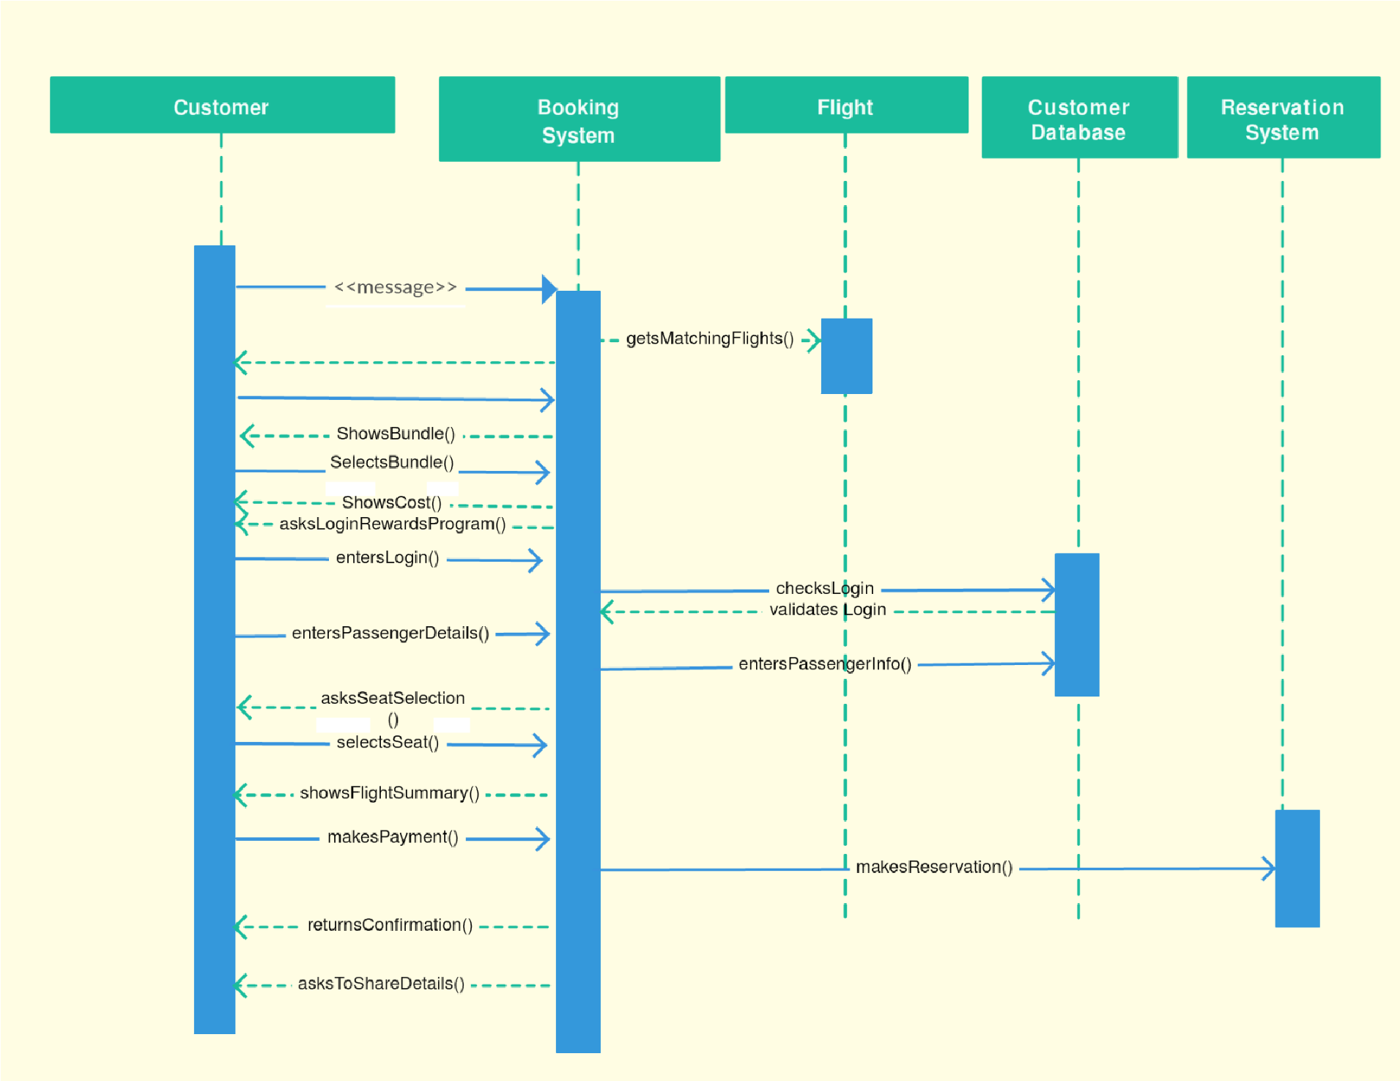

COLLABORATION DIAGRAM

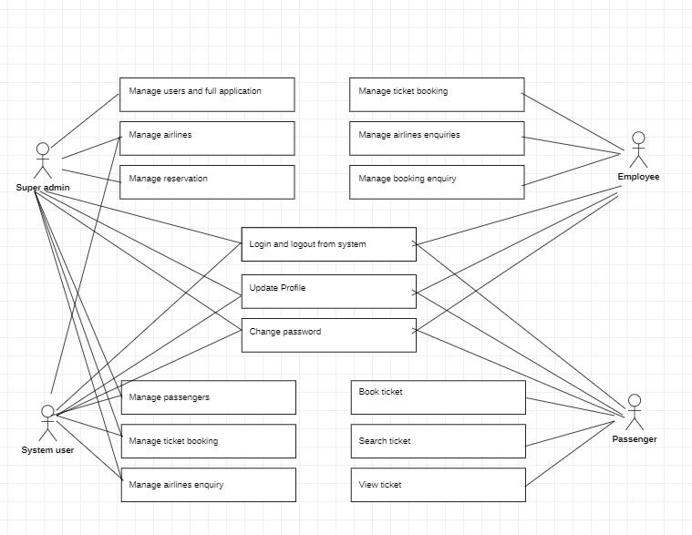



**School of Computing**

## SRM IST, Kattankulathur – 603 203 Course Code: 18CSC206J

|  |  |  |  |  |  |
| --- | --- | --- | --- | --- | --- |
| **S. No** |  | **Description** |  | **Maximum Mark** | **Mark Obtained** |
| 1 | Exercise |  |  | 5 |  |
| 2 | Viva |  |  | 5 |  |
|  | |  | **Total** | **10** |  |

### Course Name: Software Engineering and Project Management

|  |  |
| --- | --- |
| **Experiment No** | 10 |
| **Title of Experiment** | Test Cases |
| **Name of the candidate** | N. Meghana Kiran |
| **Team Members** | Sineha S  Aryan Tanay |
| **Register Number** | RA2011003011237  RA2011003011234  RA2011003011249 |
| **Date of Experiment** | 8/6/22 |

**Mark Split Up**

## Staff Signature with date

**Aim**

To develop the testing framework and user interface framework.

**Team Members:**

|  |  |  |  |
| --- | --- | --- | --- |
| **S No** | **Register No** | **Name** | **Role** |
| **1** | RA2011003011234 | Sineha S | **Rep** |
| **2** | RA2011003011237 | N. Meghana Kiran | **Member** |
| **3** | RA2011003011249 | Aryan Tanay | **Member** |

**Features to be tested:**

1.Verify that there is a portal to add new flights in the system.

2.Verify that on filling flight details like flight name, code, from and to destinations, capacity, timings, and frequency etc., new flights get successfully added in the system.

3.Verify that search results have flight details, timings and availability.

4.Verify that users can successfully select a single or more than one seat.

5.Verify that after selecting seats, entering passenger details and making payment the selected seats get booked.

6.Verify that after cancellation the seat’s status is updated to available.

Technology and Tools Used: Working Desktop, Active internet connection.



**School of Computing**

## SRM IST, Kattankulathur – 603 203 Course Code: 18CSC206J

|  |  |  |  |  |  |
| --- | --- | --- | --- | --- | --- |
| **S. No** |  | **Description** |  | **Maximum Mark** | **Mark Obtained** |
| 1 | Exercise |  |  | 5 |  |
| 2 | Viva |  |  | 5 |  |
|  | |  | **Total** | **10** |  |

### Course Name: Software Engineering and Project Management

|  |  |
| --- | --- |
| **Experiment No** | 11 |
| **Title of Experiment** | Test Cases |
| **Name of the candidate** | N. Meghana Kiran |
| **Team Members** | Sineha S  Aryan Tanay |
| **Register Number** | RA2011003011237  RA2011003011234  RA2011003011249 |
| **Date of Experiment** | 8/6/22 |

**Mark Split Up**

## Staff Signature with date

**Aim**

To develop the test cases manual for the airline reservation system.

**Team Members:**

|  |  |  |  |
| --- | --- | --- | --- |
| **S No** | **Register No** | **Name** | **Role** |
| **1** | RA2011003011234 | Sineha S | **Rep** |
| **2** | RA2011003011237 | N. Meghana Kiran | **Member** |
| **3** | RA2011003011249 | Aryan Tanay | **Member** |

## Functional and non functional test cases

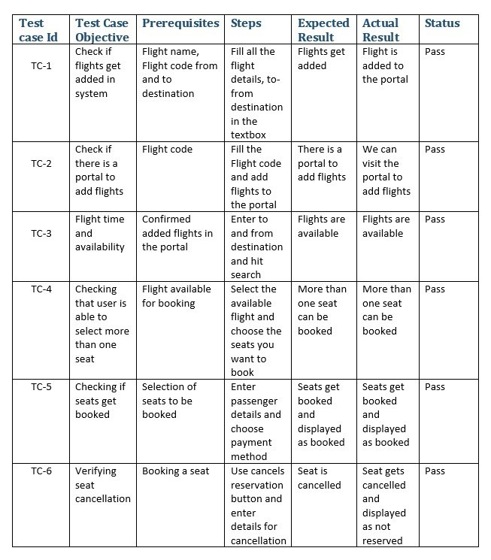



**School of Computing**

## SRM IST, Kattankulathur – 603 203 Course Code: 18CSC206J

|  |  |  |  |  |  |
| --- | --- | --- | --- | --- | --- |
| **S. No** |  | **Description** |  | **Maximum Mark** | **Mark Obtained** |
| 1 | Exercise |  |  | 5 |  |
| 2 | Viva |  |  | 5 |  |
|  | |  | **Total** | **10** |  |

### Course Name: Software Engineering and Project Management

|  |  |
| --- | --- |
| **Experiment No** | 12 |
| **Title of Experiment** | Test Cases |
| **Name of the candidate** | N. Meghana Kiran |
| **Team Members** | Sineha S  Aryan Tanay |
| **Register Number** | RA2011003011237  RA2011003011234  RA2011003011249 |
| **Date of Experiment** | 15/6/22 |

**Mark Split Up**

## Staff Signature with date

**Aim**

To develop the test cases report for the airline reservation system.

**Team Members:**

|  |  |  |  |
| --- | --- | --- | --- |
| **S No** | **Register No** | **Name** | **Role** |
| **1** | RA2011003011234 | Sineha S | **Rep** |
| **2** | RA2011003011237 | N. Meghana Kiran | **Member** |
| **3** | RA2011003011249 | Aryan Tanay | **Member** |

**Current State of Testing:** After the development, serve of tests were conducted on the performance of the application. The test conducted were both functional and non-functional.

**Functional tests** include testing of login section, notification section, search bar and code file

**Non-Functional** requirements like performance testing, speed resting were also conducted.

**Present Obstacles:** Current Obstacles include:

* Increasing the synchronization of messages.

|  |  |  |
| --- | --- | --- |
| **Category** | **Progress Against Plan** | **Status** |
| Functional Testing | Green / Amber / Red | Not-Started / In-Progress /  Completed |
| Sign up | Green | Completed |
| Login | Green | Completed |
| Search | Green | Completed |

* Increasing the speed at which the code is formatted.

|  |  |  |  |  |  |
| --- | --- | --- | --- | --- | --- |
| Non-Functional Testing | |  | |  | |
| Performance | | Green | | Completed | |
| Speed | | Green | | Completed | |
| **Functional** | **Test Case Coverage (%)** | | **Status** | |
| Module ID | 30% | | Not-Started / In-Progress /  Completed | |
| Module 1 (sign up) | 100% | | Completed | |
| Module 2 (login) | 100% | | Completed | |
| Module 3 (search) | 80% | | In-Progress | |

Result: Thus, the test case report has been created for the airline reservation system.



**School of Computing**

## SRM IST, Kattankulathur – 603 203 Course Code: 18CSC206J

|  |  |  |  |  |  |
| --- | --- | --- | --- | --- | --- |
| **S. No** |  | **Description** |  | **Maximum Mark** | **Mark Obtained** |
| 1 | Exercise |  |  | 5 |  |
| 2 | Viva |  |  | 5 |  |
|  | |  | **Total** | **10** |  |

### Course Name: Software Engineering and Project Management

|  |  |
| --- | --- |
| **Experiment No** | 13 |
| **Title of Experiment** | Test Cases |
| **Name of the candidate** | N. Meghana Kiran |
| **Team Members** | Sineha S  Aryan Tanay |
| **Register Number** | RA2011003011237  RA2011003011234  RA2011003011249 |
| **Date of Experiment** | 22/6/22 |

**Mark Split Up**

## Staff Signature with date

**Aim**

To develop the test cases manual for the airline reservation system.

**Team Members:**

|  |  |  |  |
| --- | --- | --- | --- |
| **S No** | **Register No** | **Name** | **Role** |
| **1** | RA2011003011234 | Sineha S | **Rep** |
| **2** | RA2011003011237 | N. Meghana Kiran | **Member** |
| **3** | RA2011003011249 | Aryan Tanay | **Member** |

Output:

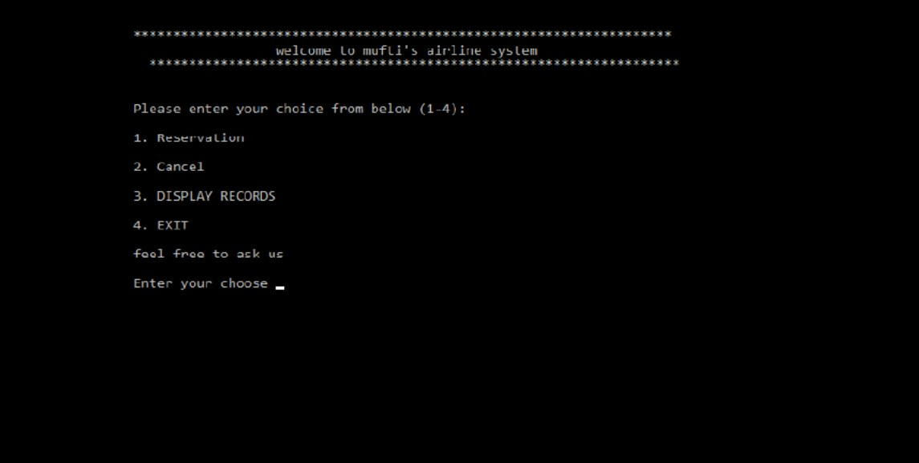

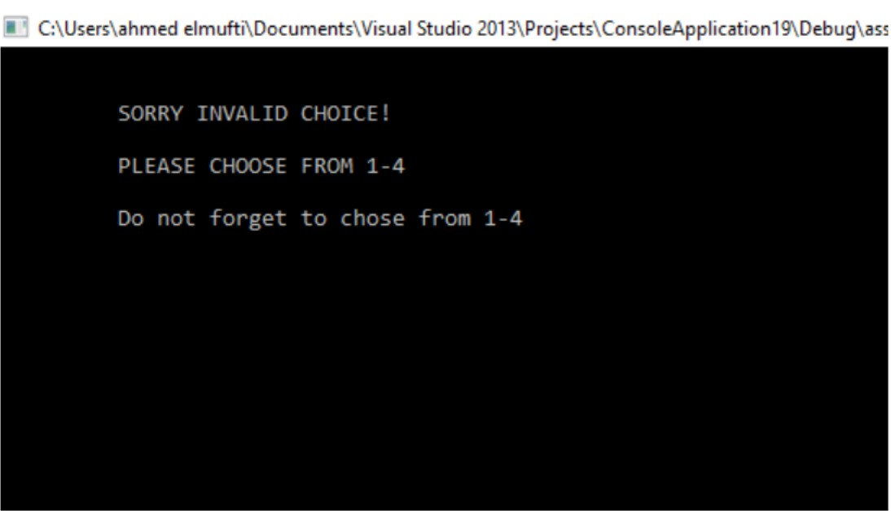

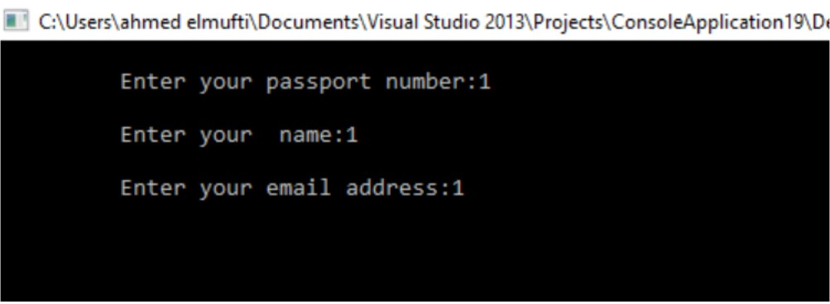

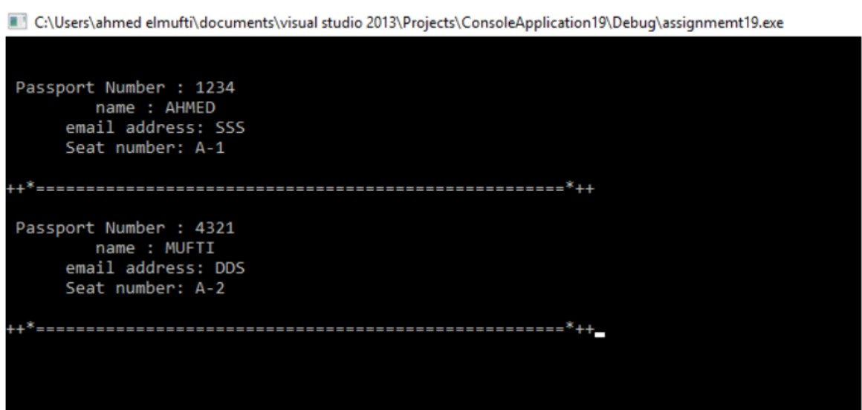

Code:

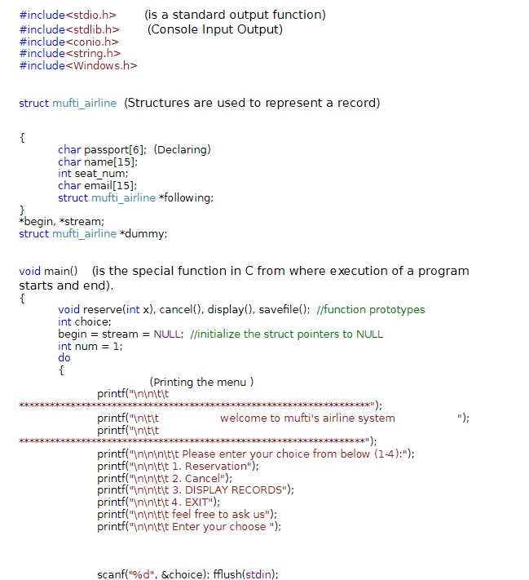

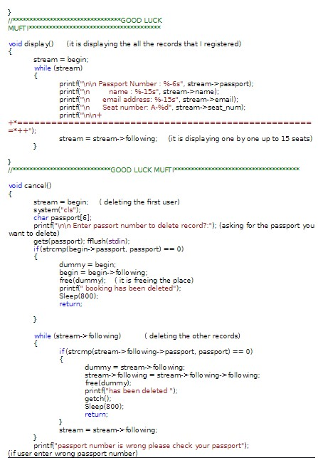

Result: Thus, the details of architectural design/framework/implementation along with the screenshots were provided.